14 TIMES WINNER OF ANS BEST REGIONAL NEWSLETTER

Southern Navion Air Group
Newsletter AUGUST 2023

Words from the President:

Hello SNAG family, I want to provide several updates to you with the first in regards to our American Navion Society convention held in June at Branson, MS. We wanted to ensure the ANS newsletter was published with all of the particular results so we waited to publish the SNAG newsletter so as not to let the air out of the ANS material. It was a very well attended fly-in and SNAG was well represented as always. We did once again win the participation trophy. I did challenge the Midwest group to “come and get it” as we could sure use the challenge and we need other chapters to participate! However, we won’t give it up easily.

The ANS has a new President, Rusty Herrington, and welcomed yours truly as a newly elected Board Member. The ANS board members are: Rusty Herrington - President, Rick Mills, Sec. / Treas., Bruce Herrington, Robert Gaines, Greg Young – VP, Beth Pontiff, David Bejvan, Eric Rice, and Kevin Domingue. I look forward to working with the other board members to continue our long tradition of the ANS serving the Navion community with parts, expertise, and fellowship. This also means that Gary Rankin’s long-standing tenure and service has come to an end for him and Alyce. After over 20 years of service, ANS did recognize their service at the banquet with designating Gary as an honorary board membership as emeritus. The board is ready to move forward with an on-line membership which will be finalized in the next several days. This means that the SNAG membership will follow soon after. To restate the approved plans for SNAG, we will migrate the membership process to an on-line option to keep our member database that will also provide an electronic means to pay your membership. The SNAG newsletter will also be kept on-line but as previously stated will also keep mailing to the members that want a mailed copy. We have been waiting on the ANS board to finalize their web option so SNAG can join as a chapter option to the parent club (ANS).

In preparation for next year’s fly-in schedule, I urge those that can step up to host a fly-in, to please volunteer. We need a fresh outlook on places to visit and ideas to refresh on things to do. I will give you a hint on the easiest way to host a fly-in; I always look for an airport with friendly staff and willing to help with transportation and the local scene on things to do. For example, for our upcoming fly-in to be held at Fayette, County, TN, I reached out to the airport manager, Rusty Bliss, he returned my phone call, welcomed us, arranged the rental cars, has arranged the meals to be held at the airport facility, and gave me a local hotel contact. It was literally as easy as that. These smaller airports want to be involved and are glad to help and facilitate our pilots and their friends. In conclusion, I need your volunteer help! I will guide you through the checklist and will provide the support you need to ensure it is successful and fun.

In preparation for my last year as President, for the third time, I plan on working on our joint participation with other clubs such as the Midwest, attending the IV Presidential fly-in to meet & connect with them, and work with our parts suppliers to open lines of communication to help facilitate all of us for a future fly-in of 50 Navions in 2024-2025. How special would that be! On a club level, I am working on SNAG welcome banners, vehicle magnetic crew car signs, and our next year’s schedule of events. I plan on making joint fly-ins with other clubs an annual event. At least one time per year.

As always, I am happy to serve, and provide a little background on what’s happening. If you have any suggestions or want to volunteer for a fly-in, please reach out to me, Susan or Lee Holmes, or to our VP and next Year’s President in waiting, Paul Wright.

Blue Skies & Tailwinds,

Kevin Domingue
409.656.4444
Kevin.Domingue6429@gmail.com

FLY-IN SCHEDULE:

- November 3-5, 2023 – Fayette County, TN (KFYE) – Joint Fly-in with the Midwest Chapter
  - Fairfield Inn & Suites Memphis/Arlington $179/nt. 901-245-0640
Book your group rate for SNAG - Southern Navion Air Group
The Blue links are active links to click and book to the hotel
SNAG - Southern Navion Air Group
Start Date: Friday, November 3, 2023
End Date: Sunday, November 5, 2023
Last Day to Book: Sunday, October 1, 2023
Hotel(s) offering your special group rate:
- Fairfield Inn & Suites Memphis Arlington for 179 USD per night
- Book your group rate for SNAG - Southern Navion Air Group

UNCLE SNAG NEEDS YOU… TO HOST A FLY-IN!
Your SNAG leadership really needs our members to step up and host some fly-ins. The same handful of members are continually hosting the vast majority of our events. Our goal is to spread our events across the entire SNAG region and have someone “reasonably” close host the event. We’ll teach you, help you and support you if it’s your first event. We’d never hang someone out to do one by themselves and once you’ve done one, you’ll see they’re really not that difficult. We have a great checklist from the McSpaddens’ with all the instructions anyone needs to host a fly in! Contact Lee Holmes for a copy (254) 780-6038. What a great way to show off a favorite airport, city or region. If you are willing to consider hosting a fly-in for the 2024 season or early 2025, please contact Kevin Domingue at Kevin.Domingue6429@gmail.com or 409.656.4444

IS A PAINT JOB IN YOUR NAVION’S FUTURE?

Depending on how you store your plane and how highly you value the appearance of your Navion, modern paints frequently hold out for 20 or more years. N48JR “Junior” has always been hangared inside and the overall look and sheen are still acceptable. However, there are some dings and filiform corrosion which are semi-justifying me beginning my journey back to a war-bird paint scheme (which is the real reason Susan and I want to get her painted). If you haven’t looked at a “down-to-bare-metal” high-quality paint job lately, the going rate is about $20,000. You can search online for airplane paint shop ratings to get a short list of high-quality shops. I also recommend reading Aviation Consumer’s last 2-3 paint shop reviews that cover about a ten-year period and also include paint scheme design options. Managing your expectations, great communication, and researching shops seem to be the key issues associated with a satisfactory experience. The highest rated shops mostly fall outside the SNAG footprint with the exception of Hawk in Zephyr Hills, FL, and Boss Aircraft Refinishers in Salisbury, NC. There are several respected paint shops in Mena, AR., and a Google-search shows many small-shop options. Just about every large city has a couple of dedicated aircraft paint shops. After our last fly-in to Gadsden, AL, I was expecting to take my Navion to International Jets (mostly doing L-29/L-39 jets), but found they have been sold and the paint shop was spun off to form Evoke Aircraft Design and they now do only experimentals and have a 4-year waiting list! Earlier this year, I became aware of a reasonably close shop that just completed paint jobs for both Bert Zeller and Charles Wiggins This shop is named Hangar 360o Aircraft Services and is owned and run by Daniel Mosley in Bolton, MS, just west of Jackson. He’s done several WW2-era aircraft- from T-6s to P-51s to a Corsair. I was on his waiting list and planned on dropping Junior off right after the ANS Annual Convention, but a right-wing tank leak has that on hold until after I get the leak repaired. Beyond painting, the newest and hottest topic is ceramic top coatings that can allow your new $20K paint to last for years longer. Aviation Consumer also has a lot to say about these coatings and suffice to say, I’ve added that to my list of must-haves. Since I finished last in the 300-HP class in the all-out speed race, I now am required to get my new paint job so I’m not violating the McSpadden rule that you can’t be both slow and ugly. Not that Junior is ugly, she’s just “plain”, so Susan’s already picked out a modified P-51 paint job with D-Day invasion stripes that we hope to have on her by the end of the year.

SPECIAL STORY

I am attaching a little write-up Greg Young did on his Facebook page to his site as well as the SNAG site. Greg, Rusty Herrington, Tom Burlace, and Kevin Domingue participated to help long time Navioneer, 95-year-old Gene Ruder. Gene’s son, Matt Ruder, had reached out on FB for a ride a few weeks ago. It turned out we had a formation clinic the weekend of July 20th -23rd at DeKalb, Illinois which is 3 miles from Gene’s farm and strip. We arranged a 3-ship Navion formation fly-out to his farm for a visit. With a bunch of family and friends watching, we made a formation pass with smoke and then an overhead break for landing.

My plane with its air conditioning got the nod for Gene’s ride. We departed for a brief tour with Gene and his other son, Dave Ruder, on board. Just after departure we were joined by Kevin Domingue in his Navion. He joined up and we flew the remainder as a 2-ship. We returned with an overhead break to land. Consequently, we wound up with 4 Navions on the ground and 5 Navion pilots.

The Navion community really is a family. Some we see often and others like Gene and Bonnie may be years, but they’re never out of our hearts. It was a pleasure to visit with Gene and Bonnie again and to meet their sons. Thanks to my fellow Navion pilots for making this visit special. Rusty led the flight with Bill Klungle as IP and Tom and myself as wingmen on Gene’s flight. It was a special day.

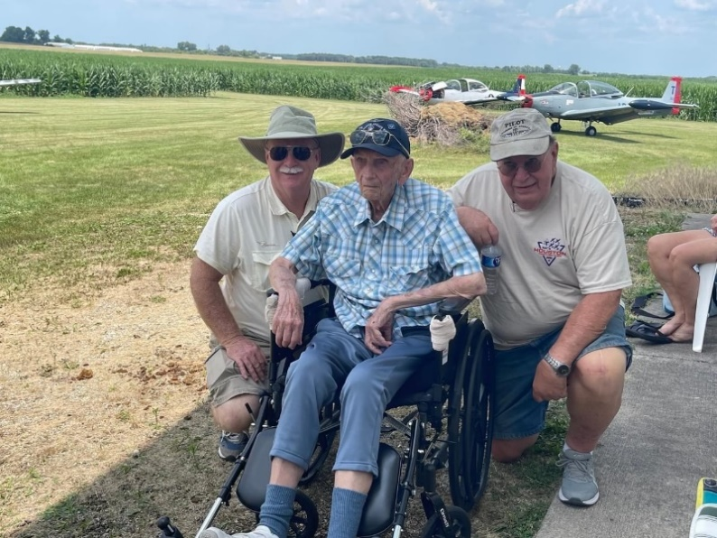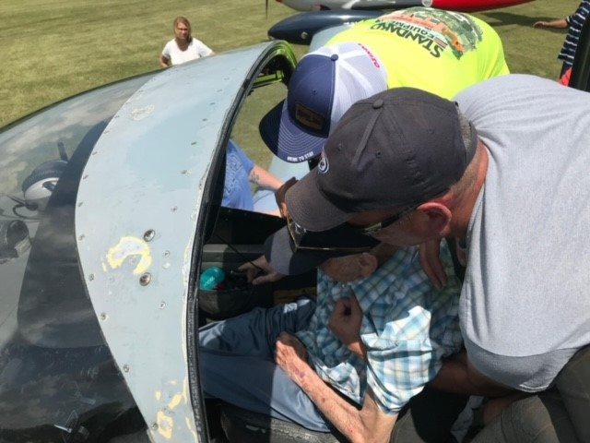

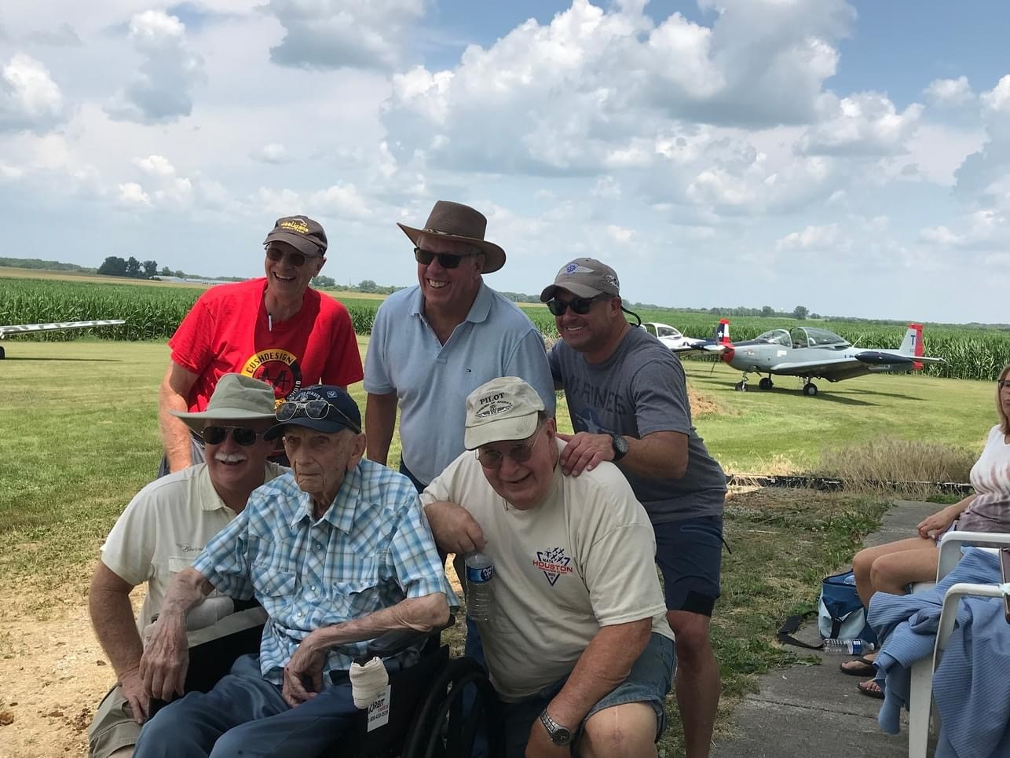

SNAG NEWSLETTER/AUGUST 2023
Lee Holmes
11881 Longfellow Cir
Shreveport, LA. 71106

